**Installing PostgreSQL:**

1. Obtain PostgreSQL (preferably v9.4.0 or above) from [www.postgresql.org](http://www.postgresql.org)
2. Install using default parameters
3. Be sure to create a unique password for the default database when prompted

**Creating a Database:**

1. Run pgAdmin III
2. Right-click the default server (expand ‘Servers’ if needed) and click ‘Connect’

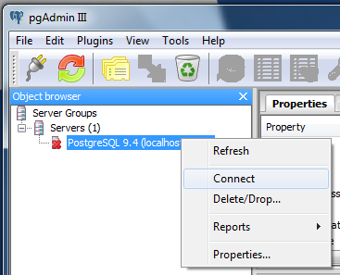

1. Enter the password set on installation

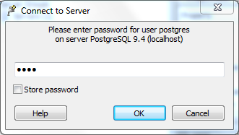

1. Right click ‘Databases’ and select ‘New Database’

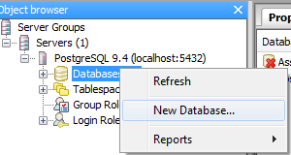

1. Enter a name for the database and click ‘ok’
2. Expand the created database menu item, right click ‘Schemas’ and select ‘New Schema’

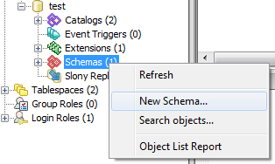

1. Enter a name for the new schema and click ‘ok’
2. Expand the created schema, right click ‘Tables’ and select ‘New Table’

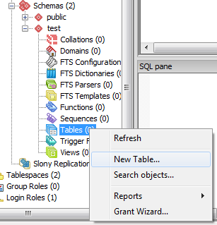

1. Enter a name for the new table and click ‘ok’
2. Expand the new table item, right click ‘Columns’ and select ‘New Column’

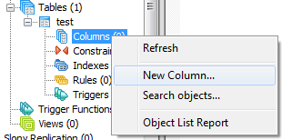

1. Enter ‘Paint Names’ for the name and ‘text’ for the data type and click ‘ok’

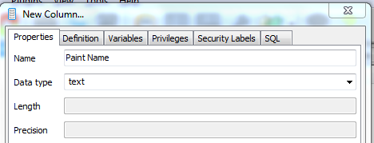

1. Create another column using ‘Litres’ for the name and ‘integer’ for the data type
2. Right click the table name, under ‘New Object’ select ‘New Primary Key’

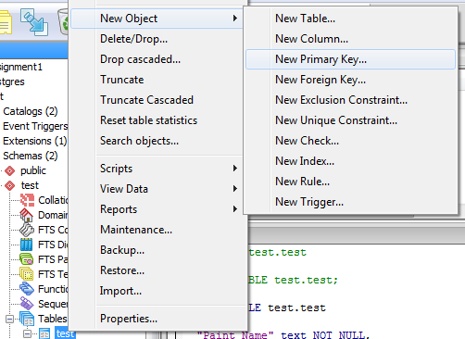

1. Under the ‘Columns’ tab, select the ‘Paint Name’ column from the ‘Column’ drop down menu and click ‘Add’

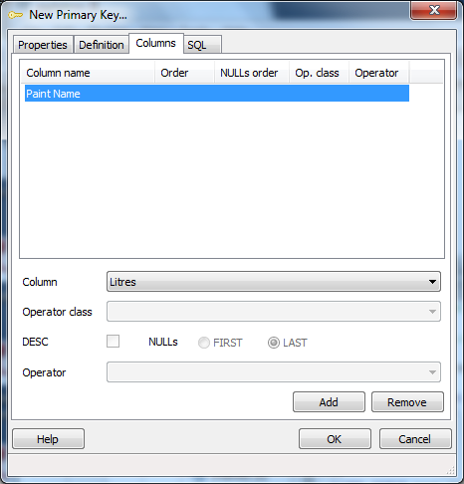

1. Select the table and click the ‘View Data’ button

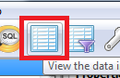

1. Fill in the data as required in the window

